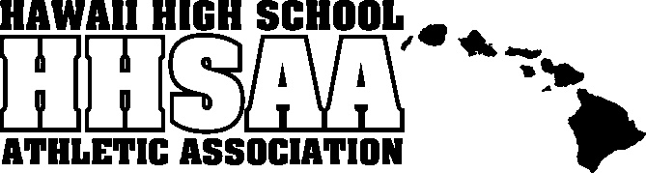
Hawaii High School Athletic Association
----------------------------------------------------------------------------------
 P.O. BOX 62029  HONOLULU, HAWAII 96839 
PHONE: (808) 800-4092
 www.sportshigh.com - info@hhsaa.org 

2019 SNAPPLE / HHSAA BOYS BASKETBALL
SOUVENIR T-SHIRT & TOURNAMENT PROGRAM PRE-ORDER FORM

School requests to order the following sizes of the souvenir Drifit T-shirts at $20.00 per shirt and Souvenir Tournament Programs at $7.00.

Size | Quantity | Price | Total
Small |  | $20.00
Medium |  | $20.00
Large |  | $20.00
X-Large |  | $20.00
XX-Large |  | $20.00
Tourney Program |  | $7.00
 |  | GRAND TOTAL
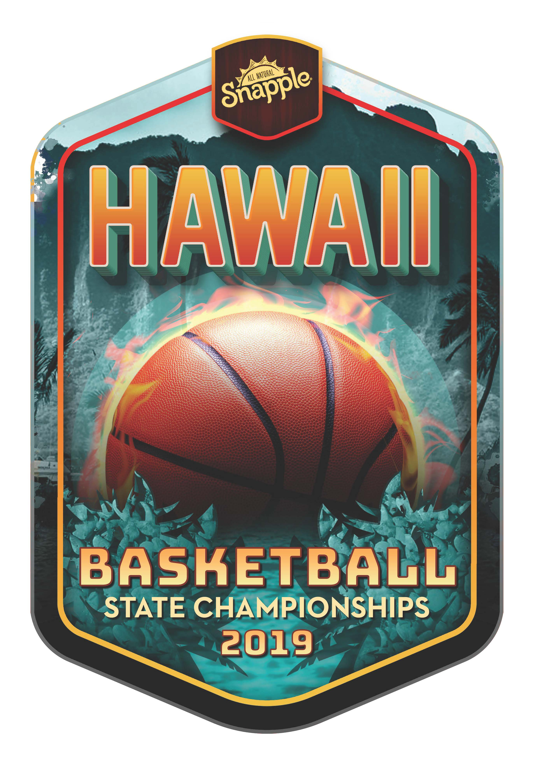

Email preorders to your respective host (see below) school. Checks payable to HHSAA may be brought to the tournament site of teams first game. Note: preorders must be paid in full by first day of the tournament or shirts will be released to the general public.

DIVISION I & DIVISION 2:
Russell Aoki - HHSAA

Contact person: ________________________

Daytime phone: ________________________

Email Address: ________________________

E-mail: aoki@hhsaa.org

